**Documentation of our thought process**

Group 1

(1) Brainstorming potential solutions based on problems

Each of us had researched some solutions and we decided on one which resounded with everyone.

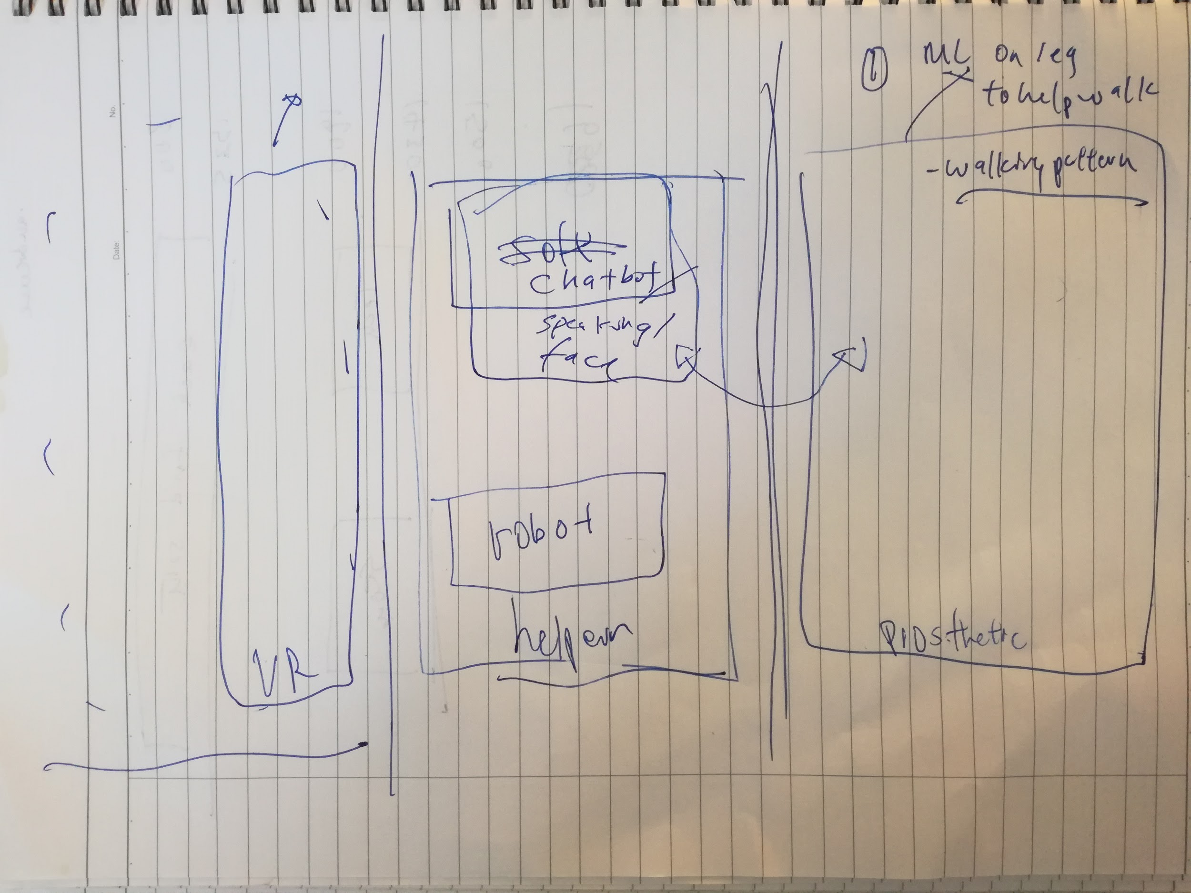

Resources:

Woebot.io

<https://www.ossur.com/prosthetic-solutions/products/dynamic-solutions/rheo-knee>

<https://projects.propublica.org/graphics/workers-compensation-benefits-by-limb>

<http://www.singaporebikes.com/forums/archive/index.php/t-352981.html>

<https://web.stanford.edu/class/engr110/2011/LeBlanc-03a.pdf>

(2) Splitting the work into the “messaging” and “technical” aspects.

Two team members worked on the technical aspect, whereas two of the members worked on the messaging/slides and business case/feasibility for the slides.

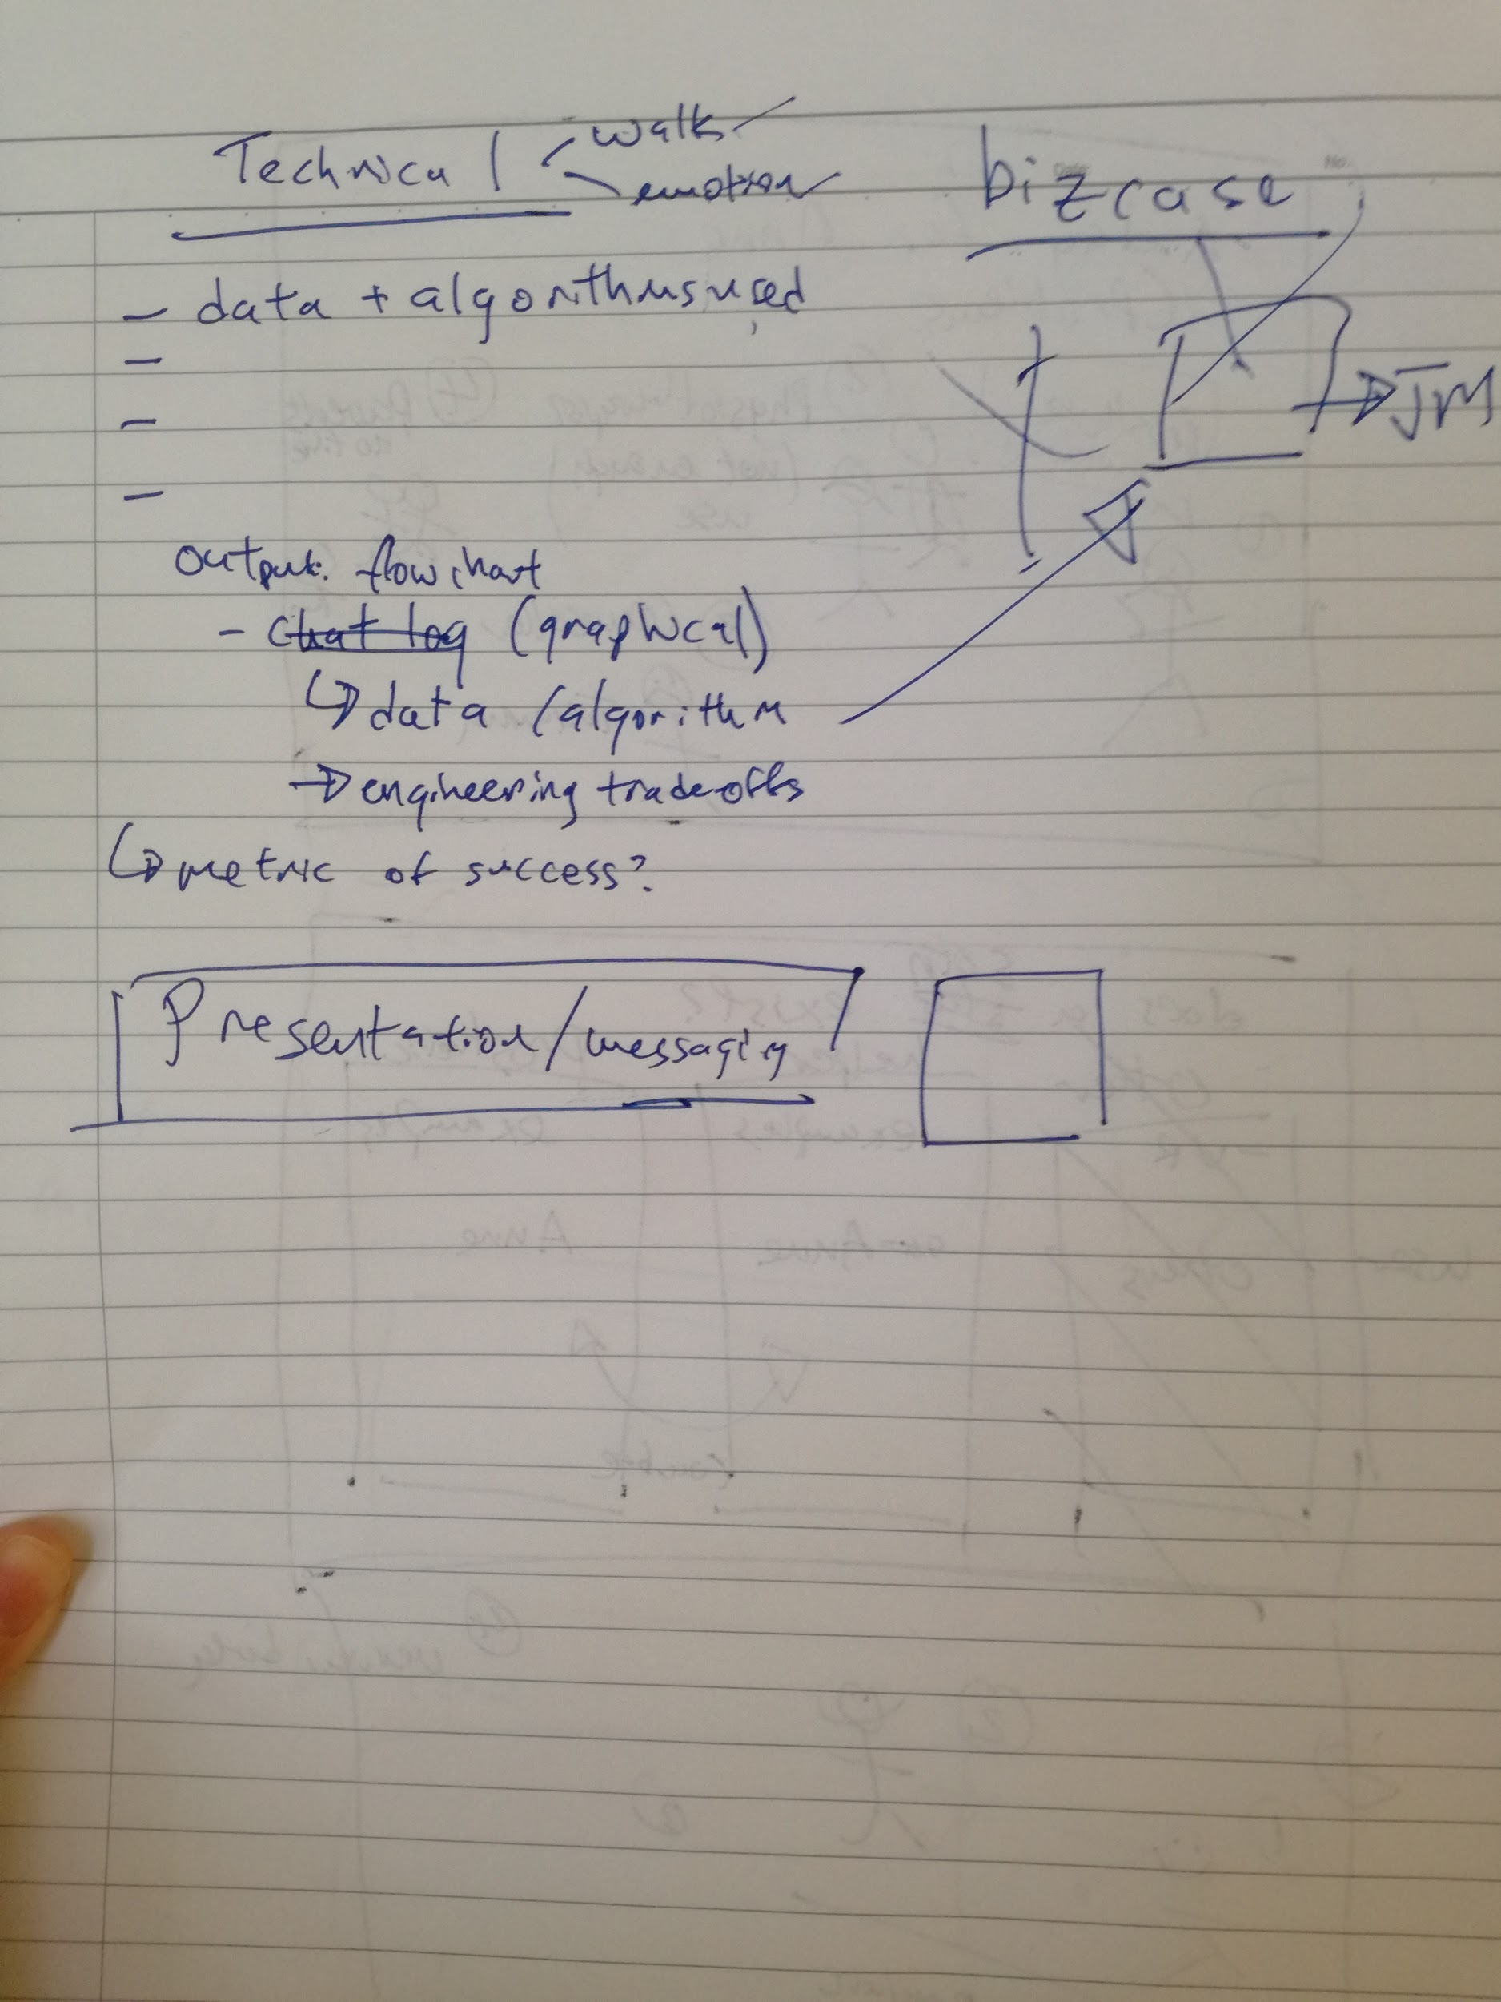

(3) Slide outline brainstorming session

Brainstormed the slide outline.

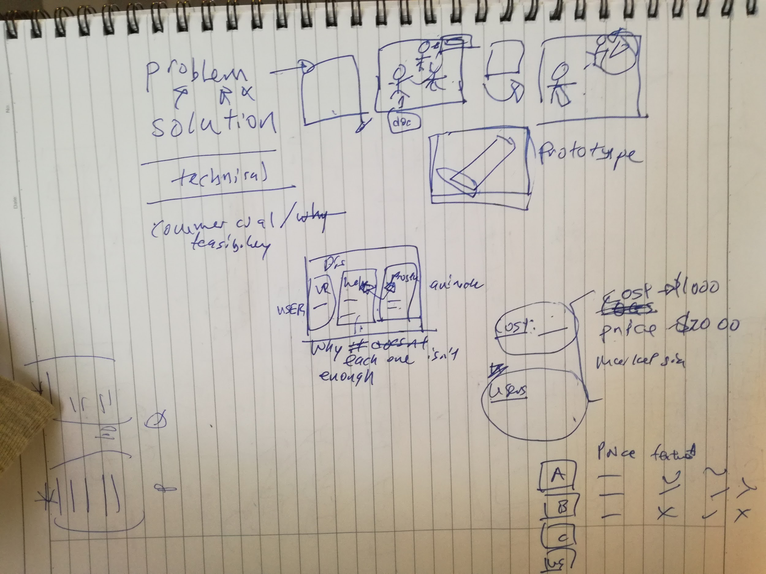

(4) Finalized slide outline

Came up with the slide outlines, divide and conquer.

